1000_PTR Enrollment initiated by EV for an Single customer Electric Meter
Contract No. 4015028196
Material No. 88000104
Serial No. 20003310
Equipment No. 100004737022
Contract Account. 100052293196
Functional Location. 6001236048

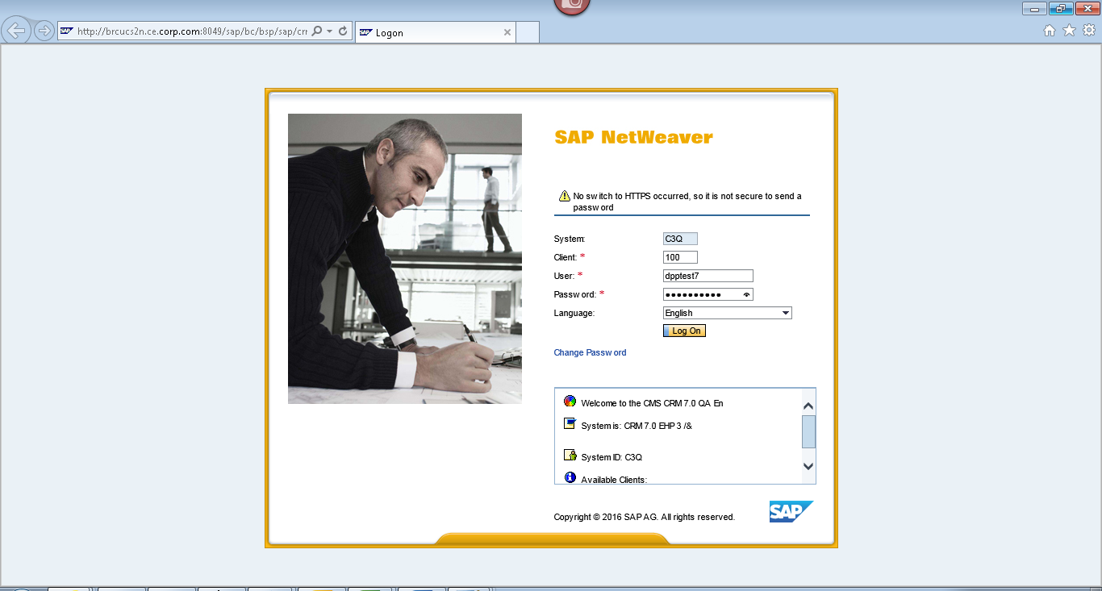
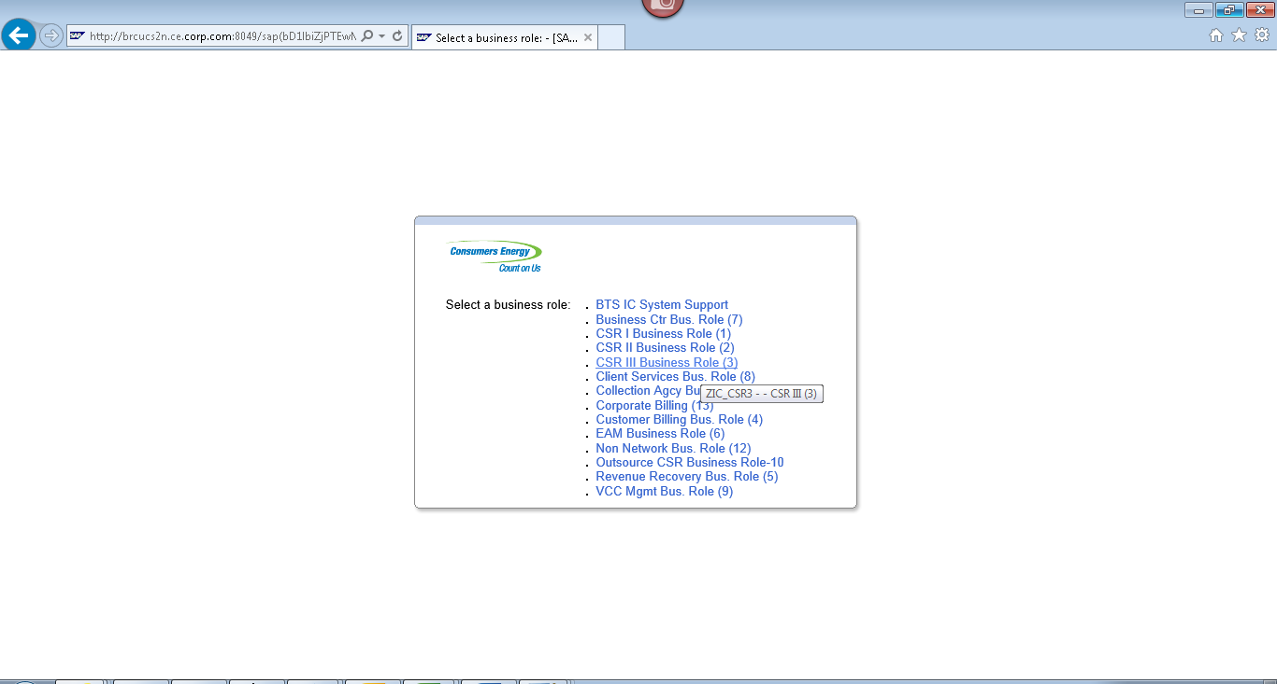
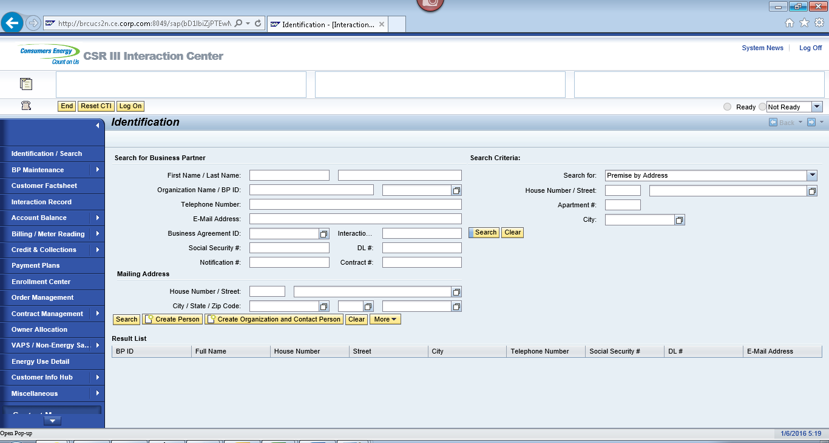
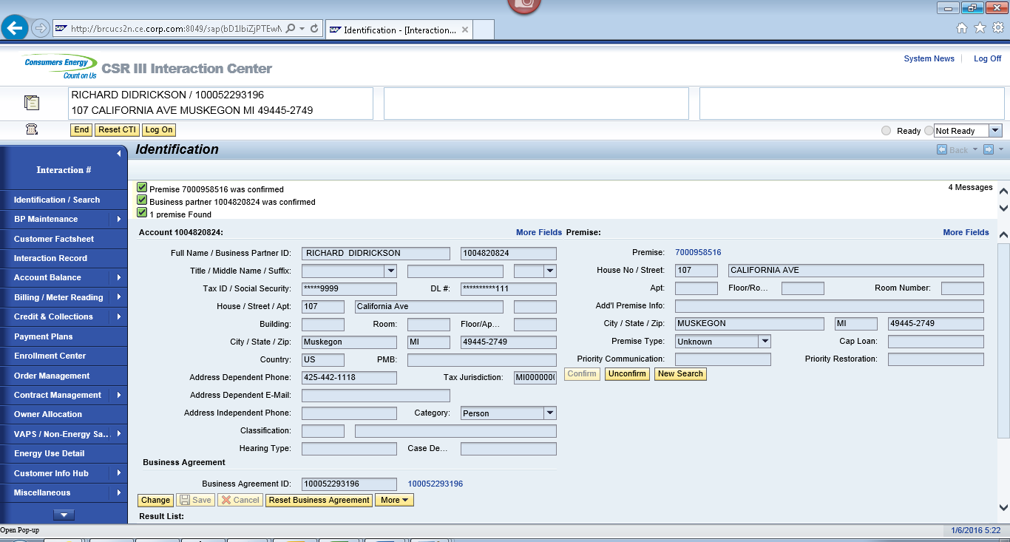
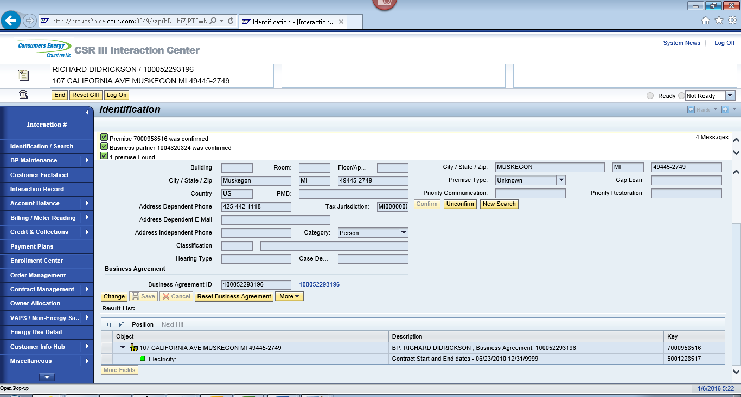
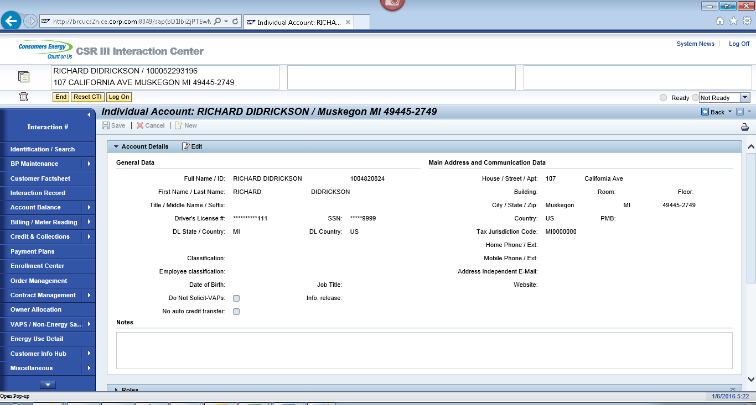
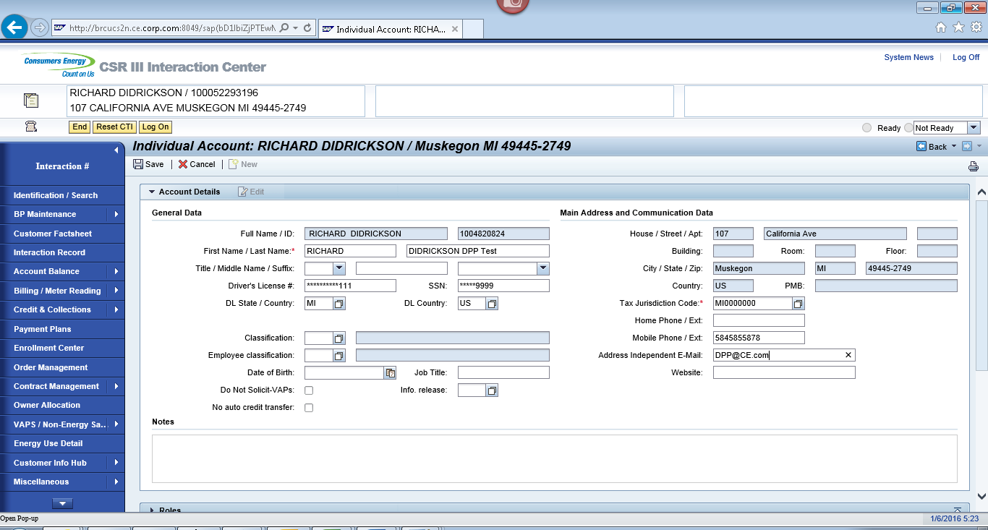
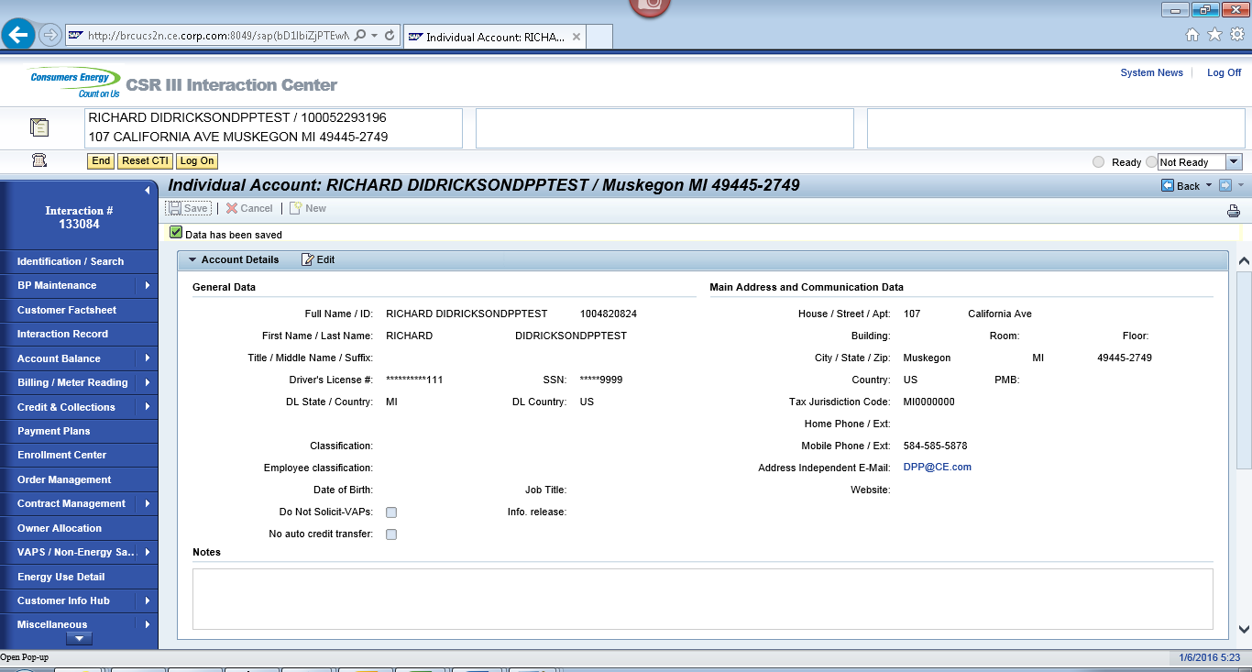
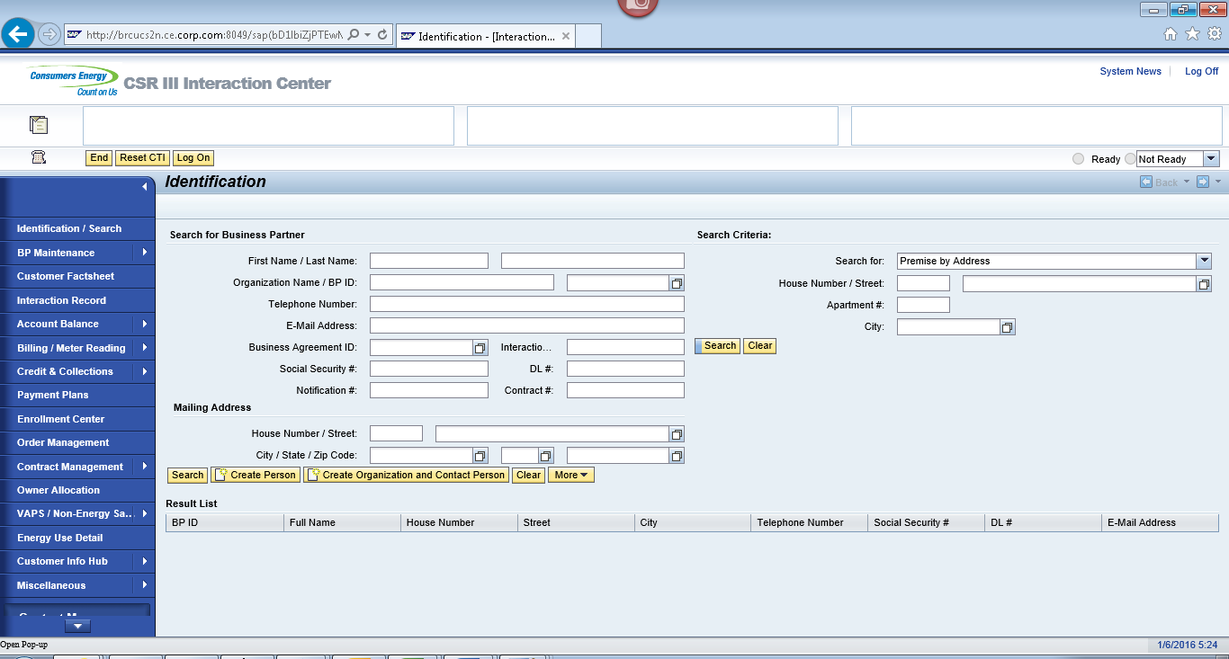
ECC
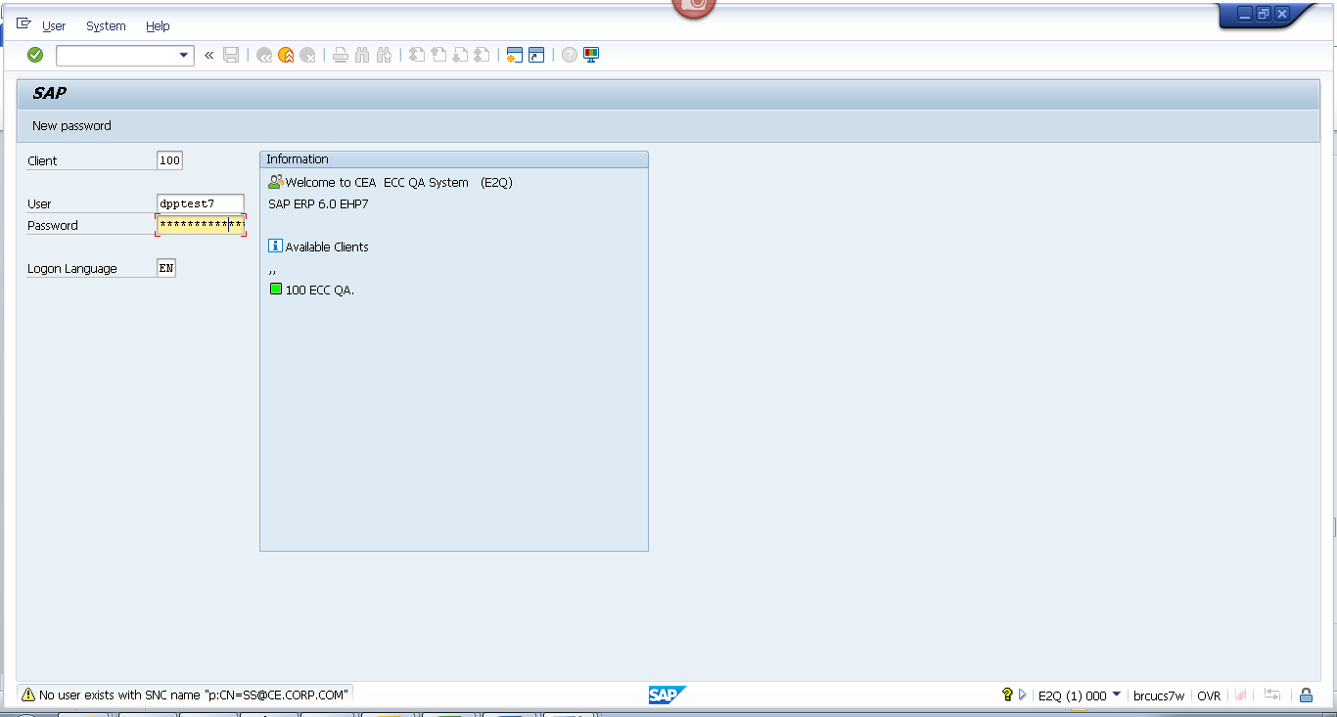
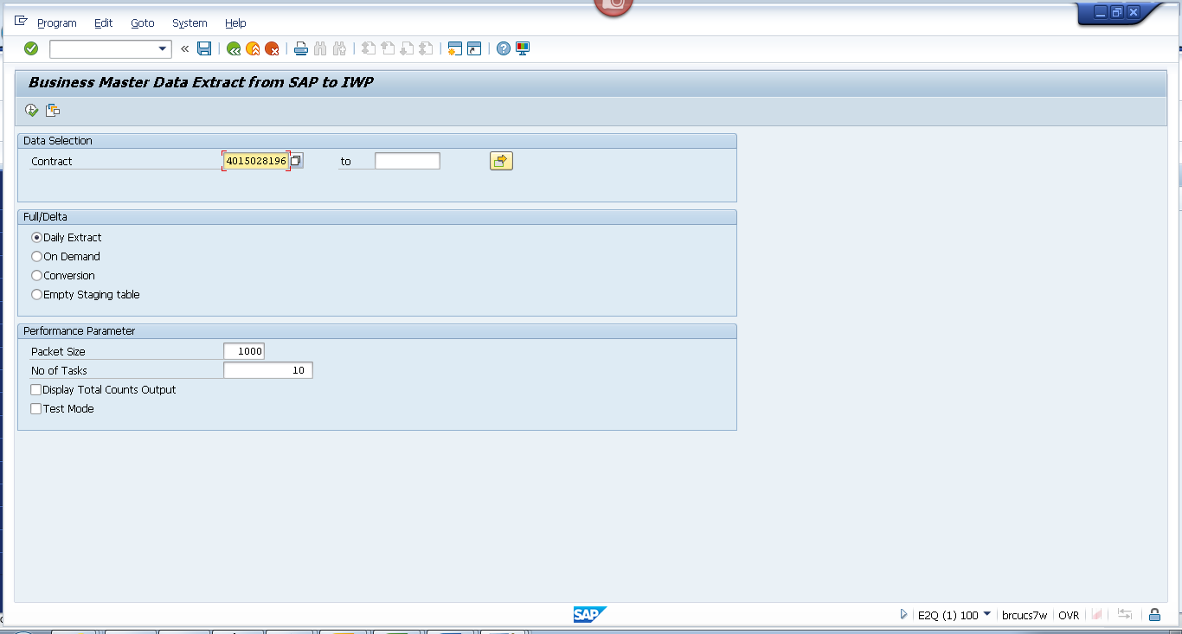
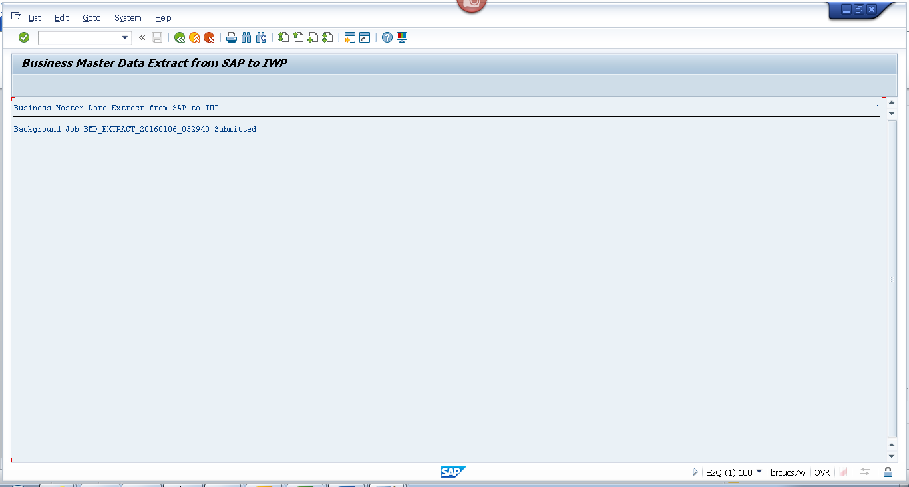
Obj tracking
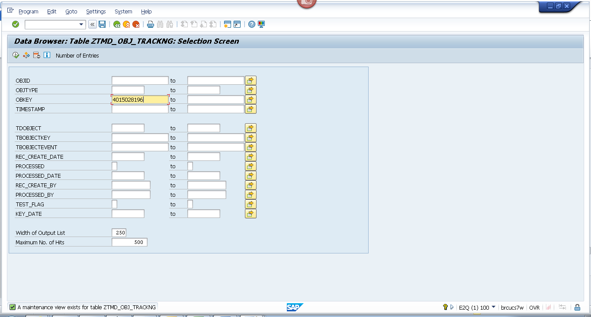
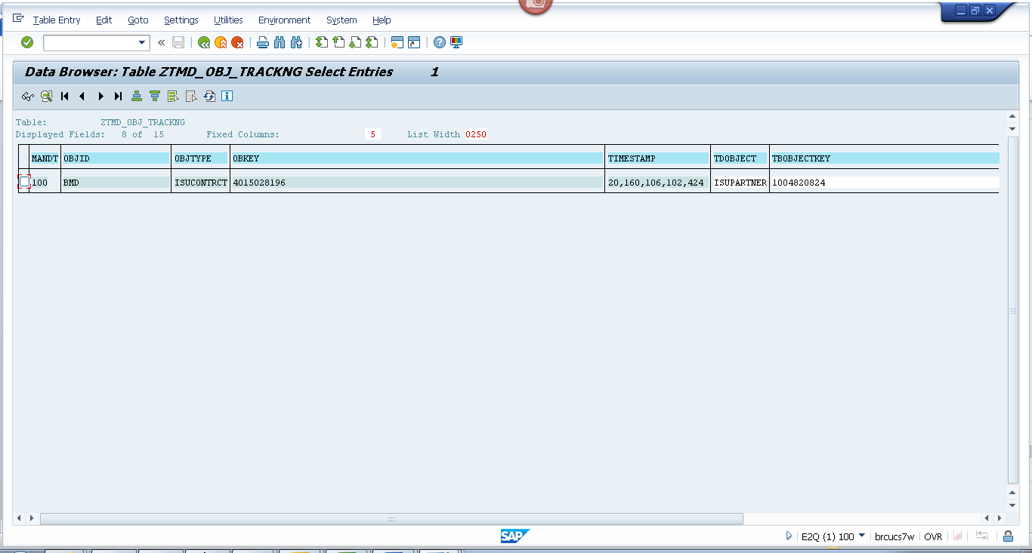
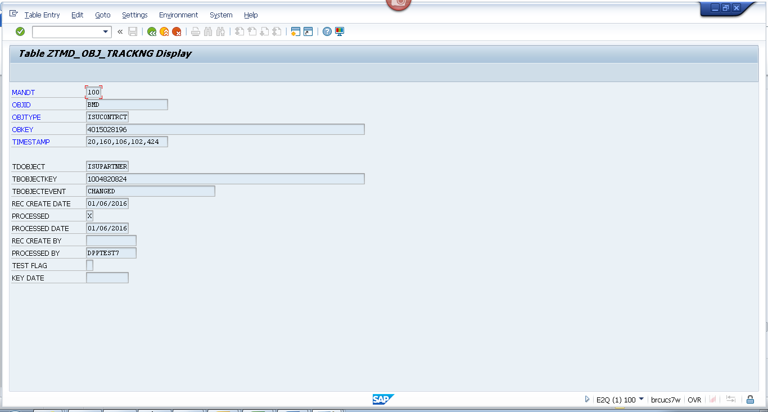
Spool
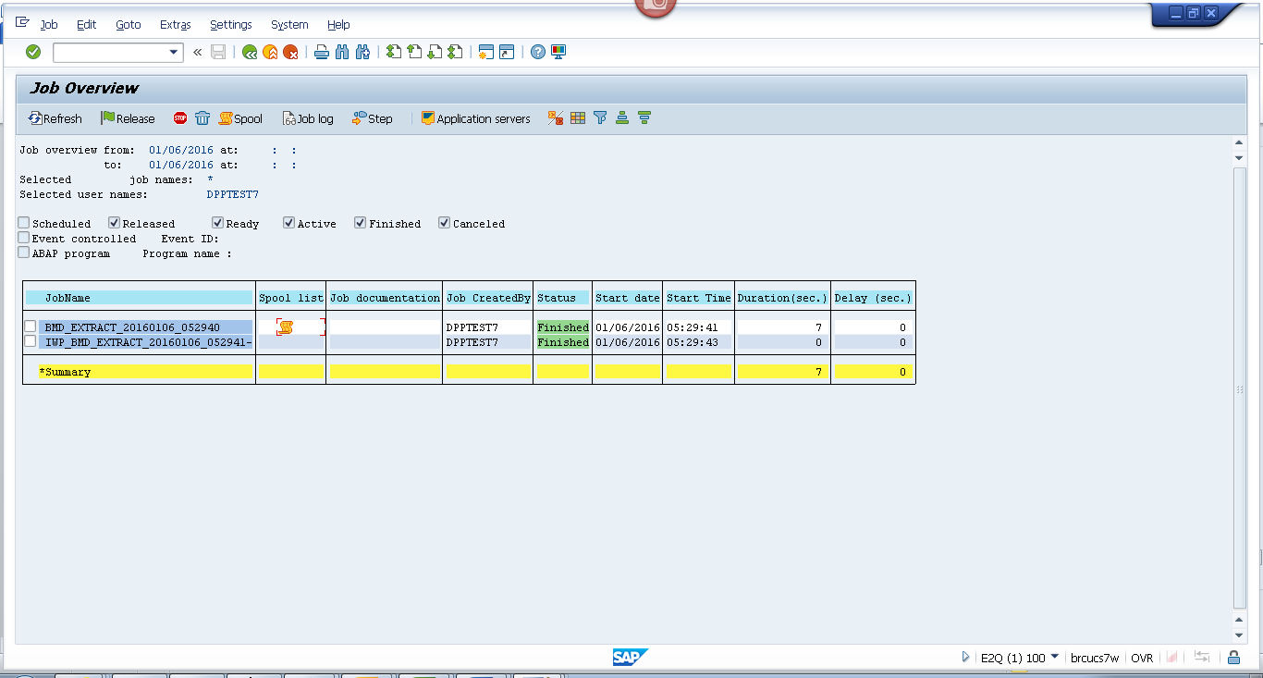
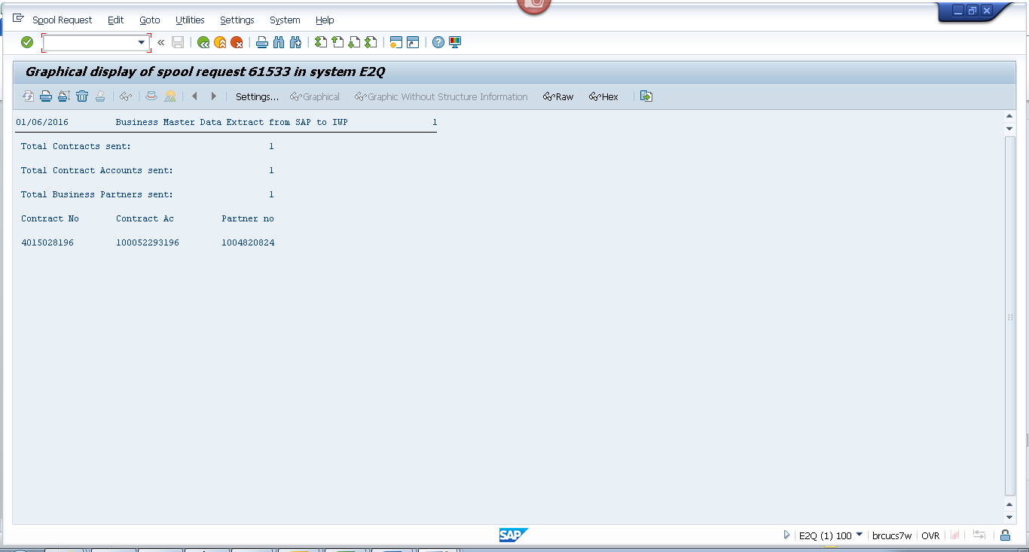
Payload
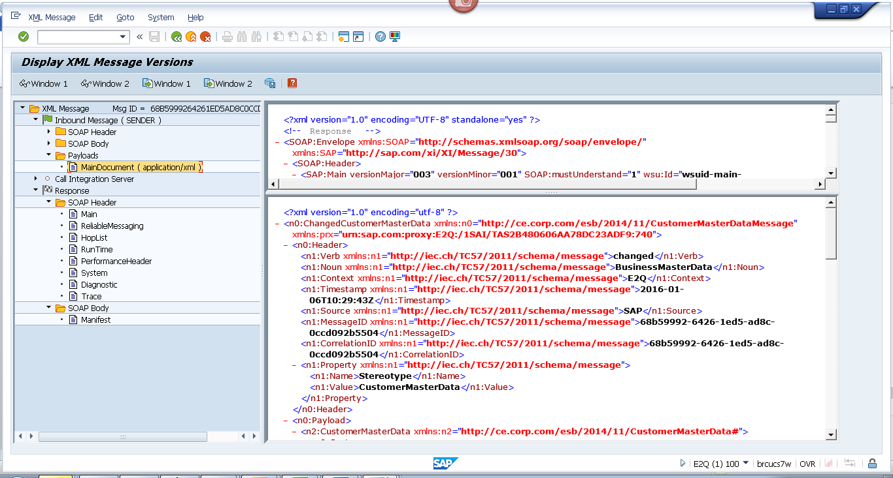
<?xml version="1.0" encoding="utf-8" ?>
- <n0:ChangedCustomerMasterData xmlns:n0="http://ce.corp.com/esb/2014/11/CustomerMasterDataMessage" xmlns:prx="urn:sap.com:proxy:E2Q:/1SAI/TAS2B480606AA78DC23ADF9:740">
- <n0:Header>
<n1:Verb xmlns:n1="http://iec.ch/TC57/2011/schema/message">changed</n1:Verb>
<n1:Noun xmlns:n1="http://iec.ch/TC57/2011/schema/message">BusinessMasterData</n1:Noun>
<n1:Context xmlns:n1="http://iec.ch/TC57/2011/schema/message">E2Q</n1:Context>
<n1:Timestamp xmlns:n1="http://iec.ch/TC57/2011/schema/message">2016-01-06T10:29:43Z</n1:Timestamp>
<n1:Source xmlns:n1="http://iec.ch/TC57/2011/schema/message">SAP</n1:Source>
<n1:MessageID xmlns:n1="http://iec.ch/TC57/2011/schema/message">68b59992-6426-1ed5-ad8c-0ccd092b5504</n1:MessageID>
<n1:CorrelationID xmlns:n1="http://iec.ch/TC57/2011/schema/message">68b59992-6426-1ed5-ad8c-0ccd092b5504</n1:CorrelationID>
- <n1:Property xmlns:n1="http://iec.ch/TC57/2011/schema/message">
<n1:Name>Stereotype</n1:Name>
<n1:Value>CustomerMasterData</n1:Value>
</n1:Property>
</n0:Header>
- <n0:Payload>
- <n2:CustomerMasterData xmlns:n2="http://ce.corp.com/esb/2014/11/CustomerMasterData#">
- <n2:Customer>
<n2:mRID>1004820824</n2:mRID>
<n2:name>RICHARDDIDRICKSONDPPTEST</n2:name>
- <n2:CustomerAccounts>
<n2:mRID>100052293196</n2:mRID>
<n2:createdDateTime>2010-06-22T04:00:00Z</n2:createdDateTime>
<n2:paperBill>true</n2:paperBill>
<n2:paymentTerm>CE21</n2:paymentTerm>
<n2:type>RES</n2:type>
- <n2:CustomerAgreements>
<n2:mRID>4015028196</n2:mRID>
<n2:accountDeterminationID>RT</n2:accountDeterminationID>
<n2:createdDateTime>2010-06-22T04:00:00Z</n2:createdDateTime>
<n2:division>ELECTRIC</n2:division>
<n2:rateCategory>RS_1000</n2:rateCategory>
<n2:startMonth>00</n2:startMonth>
- <n2:Installation>
<n2:mRID>5001228517</n2:mRID>
</n2:Installation>
- <n2:ServiceLocations>
- <n2:UsagePoints>
<n2:mRID>6001236048</n2:mRID>
</n2:UsagePoints>
</n2:ServiceLocations>
- <n2:validityInterval>
<n2:end>9999-12-31T23:59:59Z</n2:end>
<n2:start>2010-06-23T00:00:00Z</n2:start>
</n2:validityInterval>
</n2:CustomerAgreements>
</n2:CustomerAccounts>
- <n2:Indicators>
<n2:type>SENIOR</n2:type>
</n2:Indicators>
- <n2:Indicators>
<n2:type>DLA EXCLUSION</n2:type>
</n2:Indicators>
- <n2:Indicators>
<n2:type>DPP EXCLUSION</n2:type>
</n2:Indicators>
- <n2:Indicators>
<n2:type>DO NOT MARKET</n2:type>
</n2:Indicators>
- <n2:MainAddress>
- <n2:streetDetail>
<n2:buildingName>0026652401</n2:buildingName>
<n2:name>California Ave</n2:name>
<n2:number>107</n2:number>
</n2:streetDetail>
- <n2:townDetail>
<n2:code>49445-2749</n2:code>
<n2:country>US</n2:country>
<n2:name>Muskegon</n2:name>
<n2:stateOrProvince>MI</n2:stateOrProvince>
</n2:townDetail>
</n2:MainAddress>
- <n2:Persons>
<n2:firstName>RICHARD</n2:firstName>
<n2:lastName>DIDRICKSONDPPTEST</n2:lastName>
- <n2:electronicAddress>
<n2:email1>DPP@CE.com</n2:email1>
</n2:electronicAddress>
- <n2:landlinePhone>
<n2:localNumber>425-442-1118-</n2:localNumber>
</n2:landlinePhone>
- <n2:mobilePhone>
<n2:localNumber>584-585-5878</n2:localNumber>
</n2:mobilePhone>
</n2:Persons>
</n2:Customer>
</n2:CustomerMasterData>
</n0:Payload>
</n0:ChangedCustomerMasterData>

